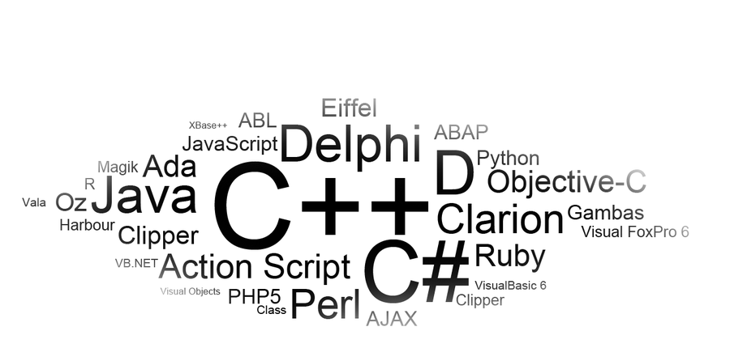




Name __________________________

Assignment 1

Decision Control Structure
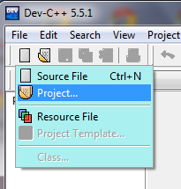
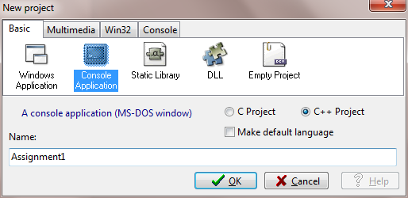
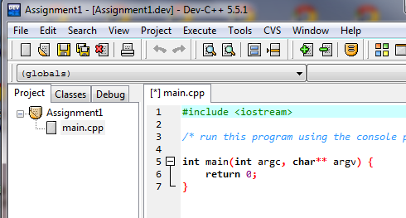

- A Project ( ___.dev) may contain a main function and other functions plus other types of files. How do you create a Project?
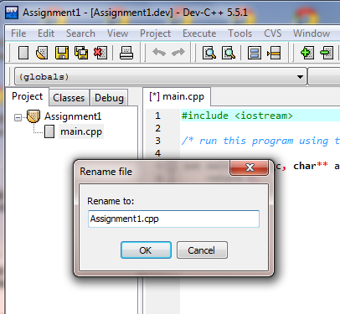

- Why do we create a Console Application?

- When you create a Project it creates a main function.
Does this code compile and run?

- How do you rename the main function file?

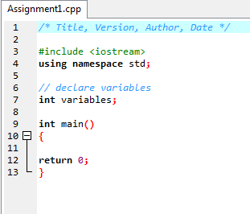
- What is the purpose of the comment area at the top?
/* Title, Version, Author, Date */

- What is the difference between /* ___ */ and // _____ ?

- At what point in your program do you need to add
#include <iostream> using namespace std;?
That is, what does this code do?
- When do you need to add the variable declaration area?

- Can you have a program without the main function?
[Have you tried taking it away to see what would happen?]

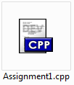
- If you develop a Project it develops a main function with a file extension of .cpp. When you compile the Project it…
--- includes code from library functions such as <iostream> and others to instruct the computer how to handle cin and cin and endl and other commands

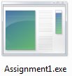

It also creates a couple of other files (to the right). Explain what these files are
and why they are created:
___.o (object) file

___.exe (executable) file

- What is the purpose of the { } (brackets) in a program, that is, when do you need to use them?

- Examine the “Green Fields Landscaping” problem on the separate sheet. What is the strategy suggested to convert a problem in natural human language into objects and tasks?

- What is the purpose of a flowchart?
Why is creating a flowchart a good strategy before coding the program?

- What do each of the following flowchart symbols represent?

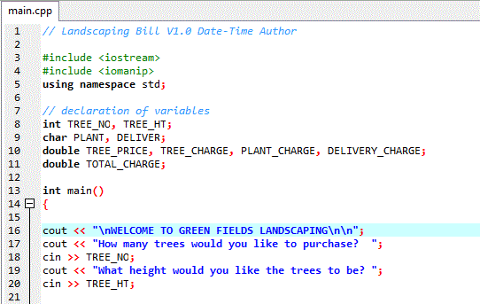
- The area where you declare variables or constants can contain three parts – the name of the variable or constant, its data type, and an initial value.

Give an example of the value that a variable of each of the following data types would have:
int - char - double -

- The variables above in the landscaping problem do not have initial variables.
When would they need to be given an initial value in the declaration area?

- Show what the display would look like with the code to the right (you do not have to write out the full text or question)?

- Complete the code for the first part of the flowchart of the landscaping problem:
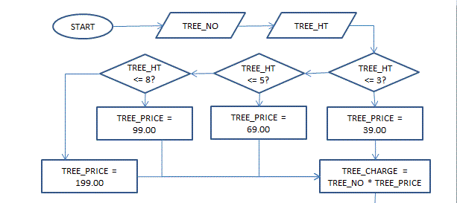
if ( )

else if ( )

else if ( )

else

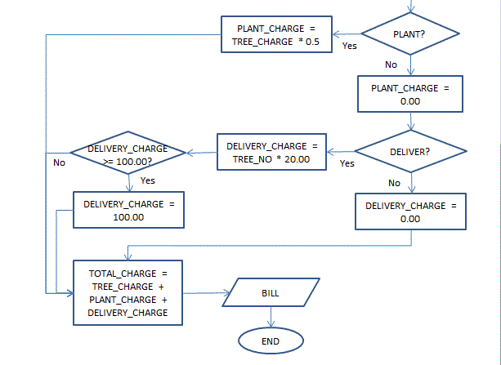
- The second part of the code is a bit more
complicated because it involves nested if..else statements. Can you code this part of
the flowchart?

01 cout <<
02 cin >> PLANT;
03 if (
04
05
06
07
08
09
10
11
12
13
14
15
16
17
18
19
20
21
22
23
24
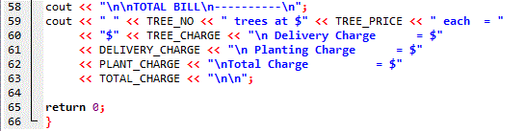
25 --- display bill section ---

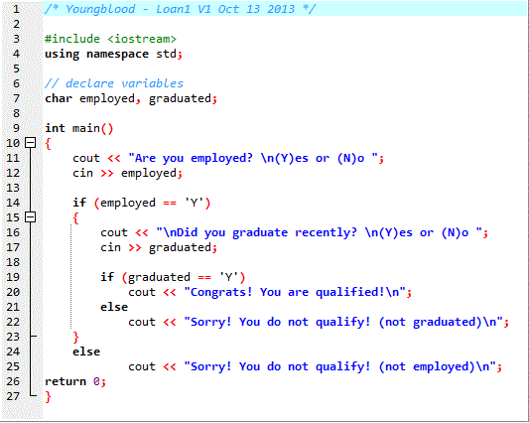
- Examine the code to the right. Draw a flowchart to show the logic of this program (shorten the quoted text to a word or two):

Note that the above program has two conditions (employed and graduated). Multiple conditions can be expressed in one condition statement using logical operators such as || for “or” and && for “and.”

- Rewrite the code for the above program using the appropriate logical operator ( || or && ):

01 cout << “Are you employed? \n(Y)es or (N)o “;
02 cin >> employed;
03 cout << "\nDid you graduate recently? \n(Y)es or (N)o ";
04 cin >> graduated;
05
06 if (
07
08
09
10
11
TYPE = 2?
TYPE = 3?
TYPE = 1?
The TREE_PRICE part of the Green Fields
Landscaping problem was solved with an
if…else if…else statement. Another way to
solve problems in which conditions have
many answers/responses is to use the
switch…case statement.

- Use the switch…case statement to
rewrite the code in #18 (from the altered flowchart above in which tree heights are divided into types):

